Below are the steps to access SFTP server to perform various operations like copying file , deleting files, modifying files etc in to S3 bucket:

1. From the command prompt/Terminal
2. From Utilities(GUI)

**From the command prompt/Terminal:**

* Launch the terminal or Navigate to command prompt
* Verify SFTP is installed? (If not install the same)
* Obtain the key(private), sftp server details and User details from the team.
* Connect to sftp server as shown below to perform required actions.

$ sftp -i <private.key> <user_name>@sftp.mm1365nhd.com

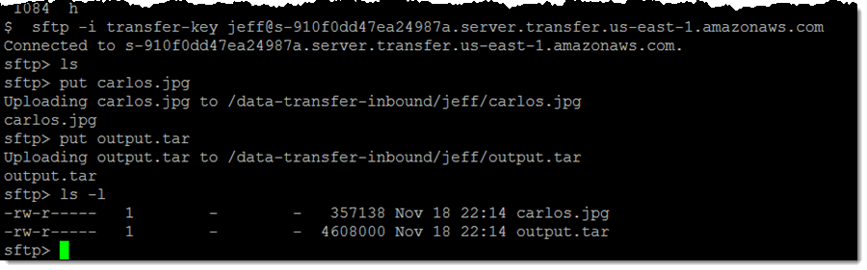

**From Utilities(GUI):**

* Install Winscp or FileZilla or similar utilities
* Obtain the key(private), sftp server details and User details from the team
* Connect to Sftp server as shown below to perform required actions